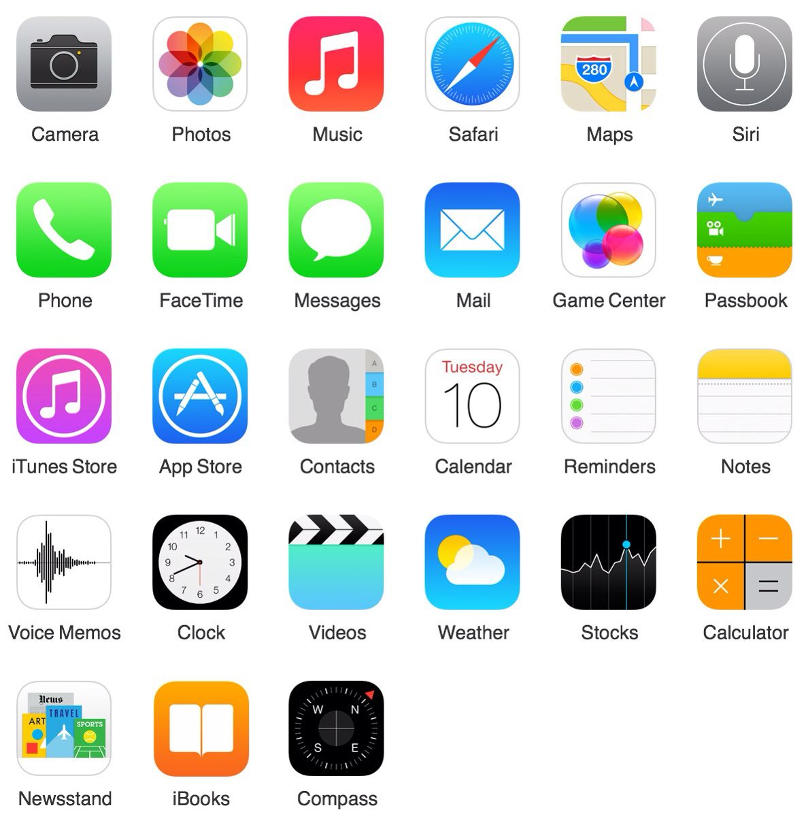
How to Get Around and Use Built-in Apps

Swiping, tapping, tapping and holding are new skills for people who've never had a touch device. You'll need to demonstrate how to move between screens, switch between apps, swipe down for the notifications bar (and search on iOS), and how to move things around by touching and dragging.

Application | What it looks like | How to use it | Notes
Phone |  | Answering a call  Hanging up the phone  Making a phone call
Contacts |  | Add a contact  Find a contact
Camera |  | Focus  Take a picture  Switch between front and back camera
Gallery |  | Find your pictures
Messages |  | Read text messages  Send text messages
App Store |  | Searching for applications  Downloading apps  Where they end up
E-mail |  | Creating an e-mail  Sending an e-mail  Moving e-mails into folders  Adding attachments
Internet Browser |  | Opening a new tab  Writing in a website  Searching on a search engine (e.g. Google)
Maps |  | Writing in an address  Finding Directions  Seeing routes with public transport
Notification Centre |  | Accessing the Notification centre (drag down from top of your screen)  What you can find there

